**Name** Mohamed Mostafa Mohamed sayed Ali **Topic**: Artificial Intelligence

**Code:** 805

|  |
| --- |
|  |

**Application Brief**

Artificial Intelligence and Machine Learning are products of both science and myth. The idea that machines could think and perform tasks just as humans do is thousands of years old. The cognitive truths expressed in AI and Machine Learning systems are not new either. It may be better to view these technologies as the implementation of powerful and long-established cognitive principles through engineering.

|  |
| --- |
| **Links**  Github link: <https://github.com/ahmed222002/html-project-repository> Github padges (puplished-website) : <https://ahmed222002.github.io/html-project-repository/>  **Source Code**  html>  <body  style="background-image:url('5.png')">  <h1 style="color:rgb(84, 240, 240);">Home</h1>      <ul>    <li><a href="What is AI.html"><H2 style="color:rgb(238, 238, 238);">What is AI</h1></a></li>   <li><a href="The Target of AI.html"><H2 style="color:rgb(243, 231, 231);">The Target of AI</h1></a></li>    <li><a href="types of AI.html"><H2 style="color:rgb(241, 231, 231);">types of AI</h1></a></li>      <li><a href="Applications of AI.html"><H2 style="color:rgb(248, 234, 234);">Applications of AI</h1></a></li>    </ul>  </body>  </html> |

**Screen Shots of WEB site**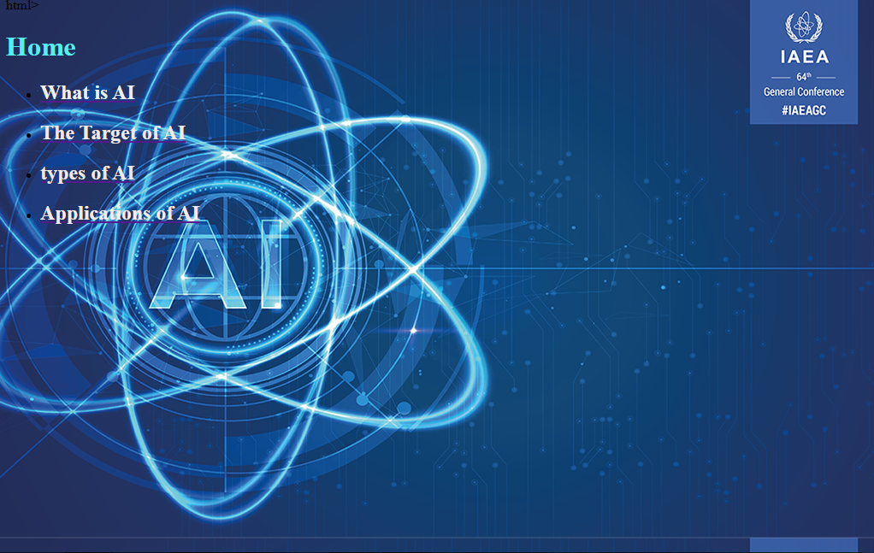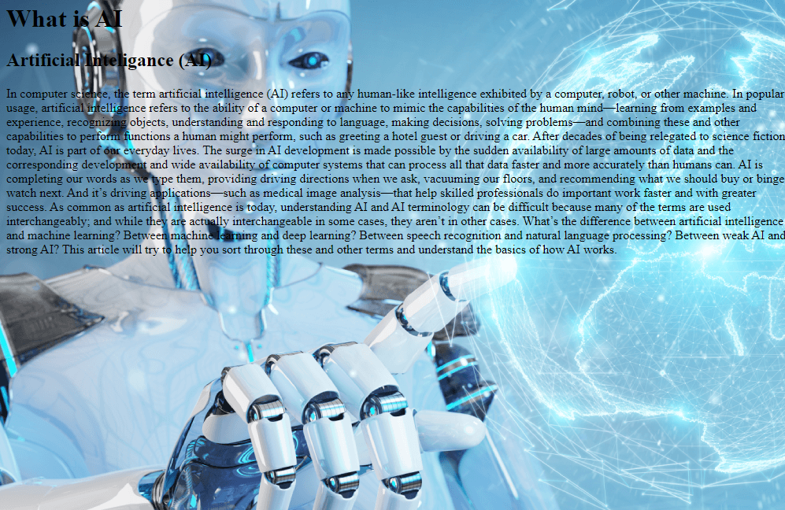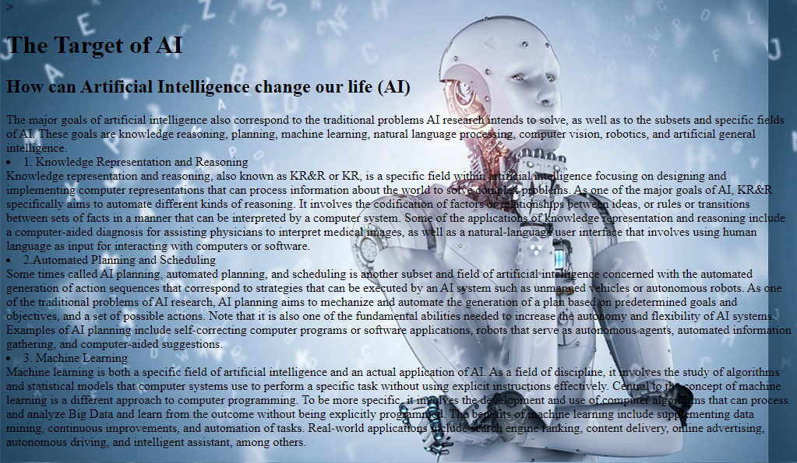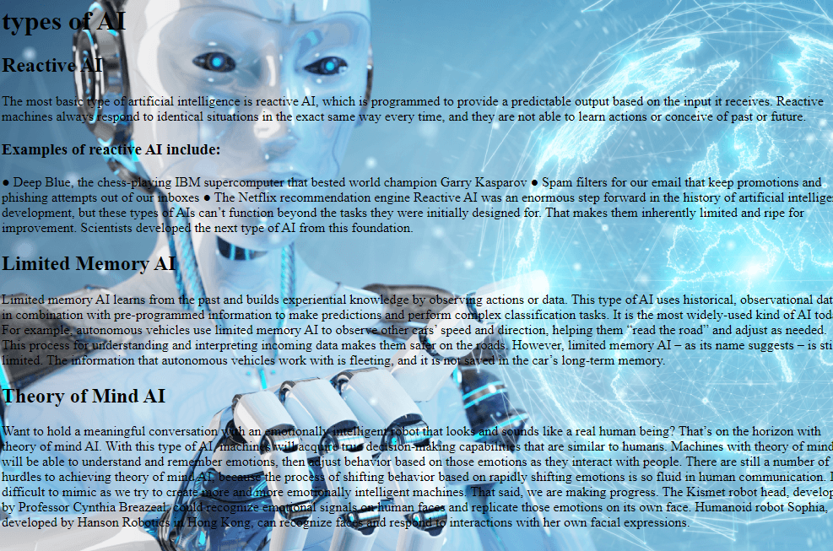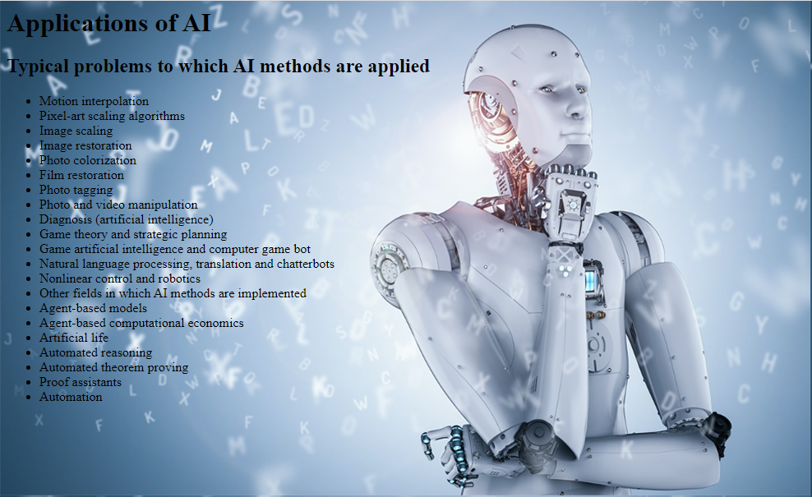

**Screen Shots of Code source** 